**Question 1:-**

As the regional manager of a pizza franchise business, you are

interested in understanding how income in a region affects pizza sales. Below is a

regression output for pizza sales (in thousands of dollars) regressed on the average

household income of an area (also in thousands of dollars).

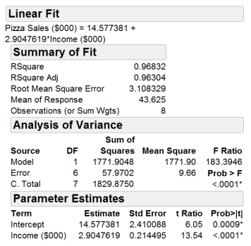

1 . What is the average pizza sales across all eight regions?

(a) $43.63

(b) $2,904.76

(c) $14,577.38

(d) $43,625

(e) Cannot determine from the JMP output above.

2. What does the p-value for the income variable (“Income ($000)”) mean?

(a) The slope of the regression line is significantly different from zero.

(b) The intercept of the regression line passes through the origin

(c) The income of a region is not significant in explaining pizza sales.

(d) Both a and c are correct.

(e) None of the above.

3. What is the interpretation of the slope?

(a) For each $1,000 increase in average household income, pizza sales increase by

$2.90.

(b) For each $1,000 increase in average household income, pizza sales increase by

$2,905.

(c) For each $2,905 increase in average household income, pizza sales increase by

$1,000.

(d) For each dollar increase in average household income, pizza sales increase by

$14.58.

(e) None of the above.

4. What does the model predict for pizza sales in a region with an average

household income of $40,000?

(a) $116

(b) $131

(c) $116,205

(d) $130,768

(e) None of the above.

5. What can you conclude from/about the estimated intercept?

(a) For the model’s fitted line, when x=0 then the model predicts that y=14.577381.

(b) The model predicts that regions with an average household income of $0 will still

have pizza sales of $14,577.

(c) The intercept must be an extrapolation from the data, since we could not have observed any regions with average household incomes of $0 (or less).

(d) All of the above are appropriate conclusions.

(e) None of the above are appropriate conclusions.

6. What is the interpretation of the R2?

(a) 0.968% of the variation in pizza sales is explained by income.

(b) 0.968% of the variation in income is explained by pizza sales.

(c) 96.8% of the variation in pizza sales is explained by income.

(d) 96.8% of the variation in income is explained by pizza sales.

(e) None of the above.

7. What is the Root Mean Square Error?

(a) It is how far off the intercept is from the origin on average.

(b) It is the estimated standard deviation of the error term in the regression

model.

(c) It is calculated as the square of the mean of the independent variable.

(d) Both a and c.

(e) None of the above.

**YELLOW HIGHLIGHTED ARE THE CORRECT ANSWERS.**